Project Plan for software development

October 29, 2019

Degree in Computer Engineering

Computer Systems Project Management

Bruno Ramos

Manuel Beijinho

Contents

Project description 3

Business objective and success criteria 3

Project scope 3

Constraints 3

SWOT analysis 4

Milestones 4

Business risks 5

Resources 5

Functional requirements 5

WBS 5

WBS Gantt-Chart 6

Revision history 7

# Project description

Social media is increasing exponentially in the lives of children, teenagers and adults. It allows family and friends to stay connected through the internet without the need to physically move to each other. Because of this ease of access, social media has been growing immensely in popularity and doesn't seem to be stopping any time soon. To accommodate this rising number of users many companies are creating more platforms, each with their own creative twist.

In this project we intend to create a platform for hobbyists to come together, share or learn more about their hobbies, whatever they may be. One example of this type of platform is [meetup](https://www.meetup.com)​. On this website you can create events for people to sign up and meet.

We believe we could bring people closer together by giving them a way of joining or hosting an event with other people and ultimately enjoy their hobby to the fullest, all the while in the presence of other like-minded people.

# Business objective and success criteria

Our business objective relies on having the greatest number of users accessing and navigating our website, where we’ll profit via the display of advertisements.

Also, when creating workshop events, the hosts will have to pay a fee for their advertisement.

For the project to succeed the website must have many active users.

# Project scope

The scope of Group Up project includes the planning, design, development, testing and deployment of the Group Up Website. The scope of this project also includes the completion of all documentation.

This project will consist of creating a website for people with the same hobbies to meet and enjoy them in the company of other like-minded people. The project will be completed by January 2020. Modules of the website include creating events, being able to see them, joining existing events and visualize them on a map.

# Constraints

|  |  |  |
| --- | --- | --- |
| Dimension | Constraint | Driver |
| Scope | Full-fledged event system |  |
| Schedule | Project duration | School project |
| Resources | HTML, JS, Node.js and CSS | School project |
| Quality | W3C |  |

# SWOT analysis

|  |  |  |  |
| --- | --- | --- | --- |
| Strengths | Weaknesses | Opportunities | Threats |
| Responsive | Innovation | Not many similar websites to date | Meetup Website |
| Design | Creativity |  |  |
| Utility | Depends on the number of users |  |  |
| User friendly |  |  |  |

# Milestones

|  |  |  |
| --- | --- | --- |
| Events and deliverables | Target date | Responsibility |
| Assemble project team | September 23, 2019 | Project manager  Development team |
| Project charter and WBS approved | November 12, 2019 | Project manager |
| Project plan completed | November 17, 2019 | Development team |
| Project plan approved | November 17, 2019 | Project manager |
| System design completed | November 17, 2019 | Development team |
| Test plan completed | December 15, 2019 | Development team |
| Integration tests | January 2, 2020 | Development team |
| Deployment completed | January 19, 2020 | Development team |
| Project closed | January 20, 2020 | Project manager |

# Business risks

|  |  |  |
| --- | --- | --- |
| Risk | Probability | Impact |
| Google maps API failure | Low | Low |
| Google sign in API failure | Low | Severe |
| Software presents security risks | Low | Severe |
| Database failure | Low | Severe |

# Resources

This project is comprised by two teams, the development team and the project managers.

The project managers are the teachers involved in the project (Miguel Bugalho, Gabriel Pestana, José Braga de Vasconcelos and Jacinto Estima). They have the responsibility of managing the project and helping the development team.

The development team comprised of Bruno Ramos and Manuel Beijinho have the responsibility of completing the project as well as learning the required skills for it.

# Functional requirements

This project’s high priority functional requirements consist of allowing the user to create an event (scheduled to be completed by November 9, 2019), display the existing events (November 23, 2019), allow users to join existing events (scheduled to be completed by November 15, 2019) and view the events location on a map and its directions (scheduled to be completed by December 20, 2019).

In order to implement this, we’ll have to create (scheduled to be completed by November 15, 2019) and connect (scheduled to be completed by November 16, 2019) a database to our website.

# WBS

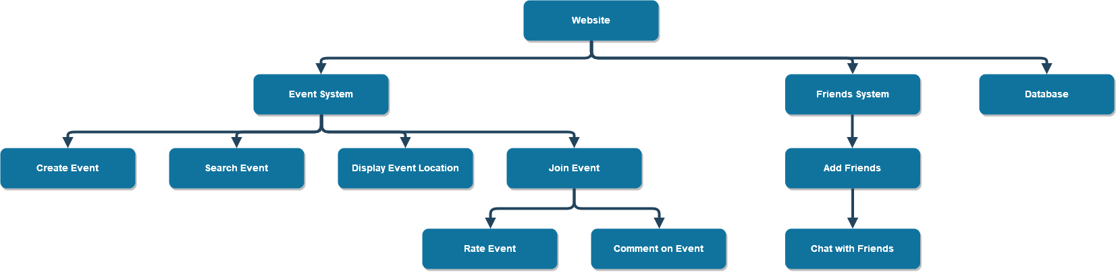

# WBS Gantt-Chart

# Revision history

|  |  |  |  |
| --- | --- | --- | --- |
| Name | Date | Reason for changes | Version |
| Group Up Project | October 23, 2019 | Document creation | 1.0a |
| Project Plan | November 5, 2019 | Updated the previous version to match Project Plan requirements. | 1.0 |
| Project Plan | November 12, 2019 | Added WBS Gantt-Chart and revised some topics | 1.1 |